Insight Stream: Navigate the News Landscape

Project Documentation

Introduction
Project Title:News Wave
Team Members:
- [Sharmila Y] – Team Leader (ysharmila0911@gmail.com)
- [Sathiya priya P] (sathyasathya88396@gmail.com)
- [Susana] (susansusan1311@gmail.com)
- [Pooja S]( poojasekar20052005@gmail.com)

Project Overview

Purpose:
The News App is designed to provide users with real-time news updates from various categories, including politics, sports, technology, and entertainment. The app fetches news from an external API and presents it in an intuitive and user-friendly interface.

Features:
- Fetch and display live news articles
- Categorized news sections
- Search functionality for news articles
- Bookmark/save favorite articles
- Responsive and mobile-friendly UI
- Dark mode toggle

Architecture

Component Structure:
- App.js – Main component managing routes and layout
- Header.js – Contains navigation and search functionality
- NewsList.js – Displays a list of news articles
- NewsCard.js – Reusable component for individual news articles
- CategoryFilter.js – Allows users to filter news by category
- Bookmark.js – Displays saved articles
- DarkModeToggle.js – Handles dark mode functionality

State Management:
- Context API used for managing global state, such as dark mode and bookmarks.

Routing:
- Implemented using React Router for page navigation:
  - / - Home (Top news)
  - /category/:id - News by category
  - /search - Search results
  - /bookmarks - Saved articles

Setup Instructions

Prerequisites:
Ensure the following are installed:
- Node.js (latest LTS version)
- Git
- Code editor (VS Code recommended)

Installation:
- Clone the repository:
sh
CopyEdit
git clone https://github.com/yourusername/news-app.git
cd news-app
- Install dependencies:
sh
CopyEdit
npm install
- Set up environment variables (e.g., API key for news API).
- Start the development server:
sh
CopyEdit
npm start

Folder Structure
pgsql
CopyEdit
news-app/
│── src/
│ ├── components/
│ │ ├── Header.js
│ │ ├── NewsList.js
│ │ ├── NewsCard.js
│ │ ├── CategoryFilter.js
│ ├── pages/
│ │ ├── Home.js
│ │ ├── Category.js
│ │ ├── Search.js
│ │ ├── Bookmarks.js
│ ├── context/
│ │ ├── DarkModeContext.js
│ │ ├── BookmarkContext.js
│ ├── assets/
│ ├── styles/
│ ├── App.js
│ ├── index.js
│── public/
│── package.json
│── README.md

Utilities:
- Helper functions for API requests
- Custom hooks for managing dark mode and fetching news

Running the Application
To start the application locally, use:
sh
CopyEdit
npm start

Component Documentation

Key Components:
- NewsCard – Displays an individual news article
  - Props: title, description, imageUrl, publishedAt, source
- CategoryFilter – Dropdown or tab-based selection for filtering categories

Reusable Components:
- Button.js – Styled button component
- Loader.js – Loading spinner

State Management

Global State:
- Dark Mode State: Managed using Context API
- Bookmark State: Stores saved news articles

Local State:
- Search Input: Managed within the search component

User Interface
Screenshots showcasing different pages and features (home page, category selection, dark mode, etc.)

Styling

CSS Frameworks/Libraries:
- Styled Components for dynamic styling
- Bootstrap for responsive layout

Theming:
- Supports light and dark mode using CSS variables

Testing

Testing Strategy:
- Unit Tests: Using Jest and React Testing Library
- Integration Tests: Testing API requests

Code Coverage:
- Ensuring test coverage for major components

Screenshots or Demo
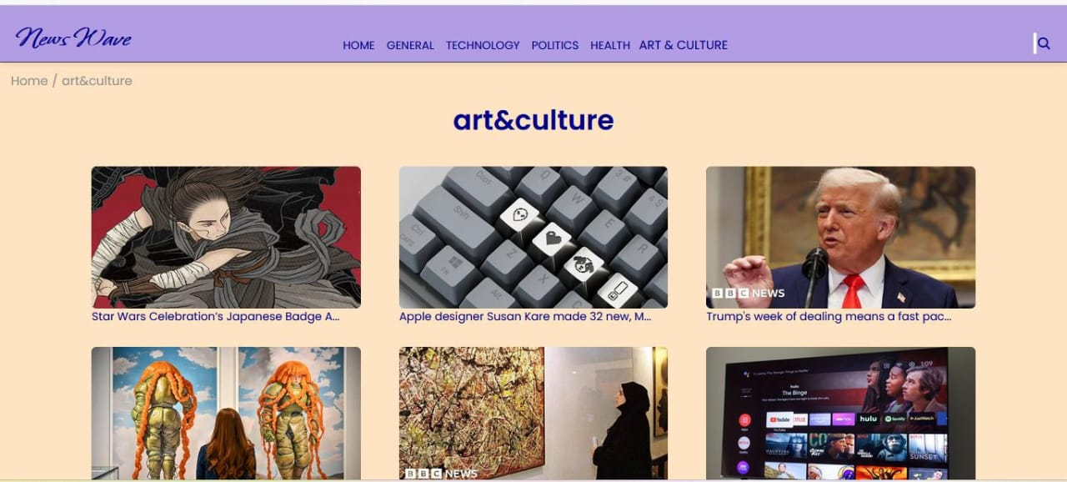
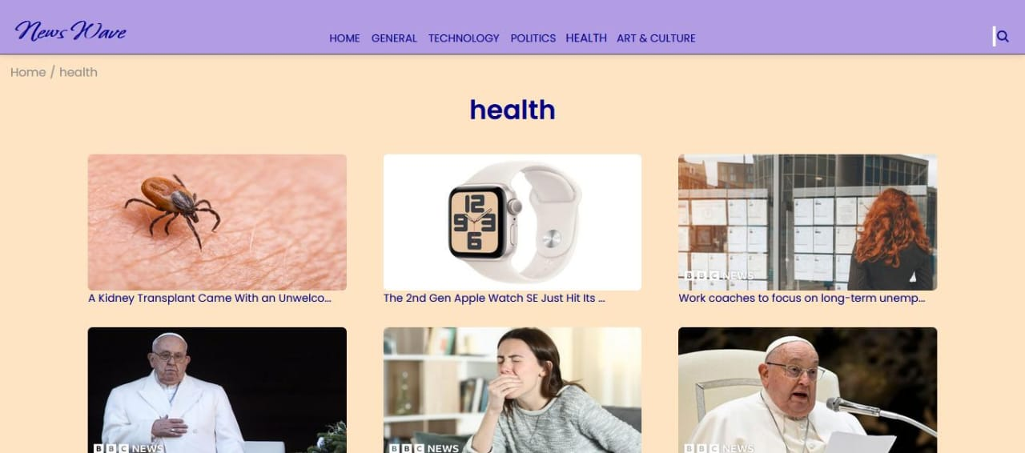
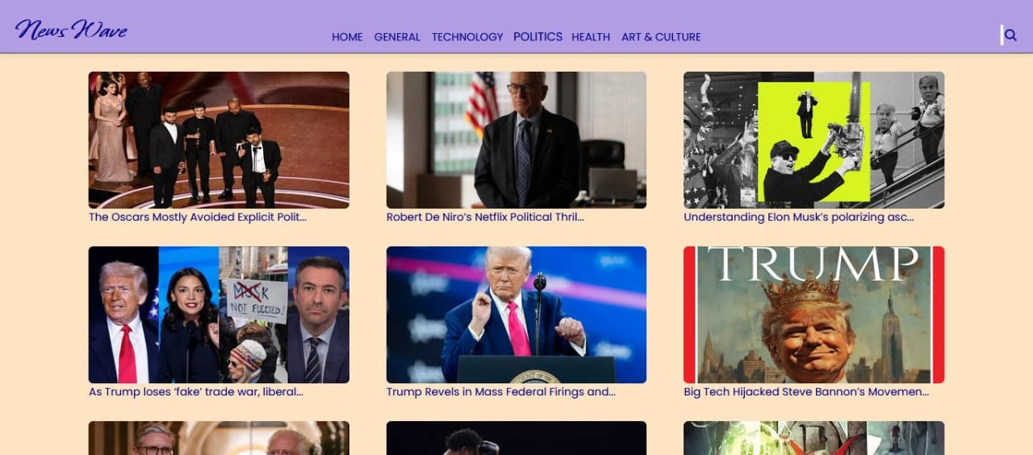
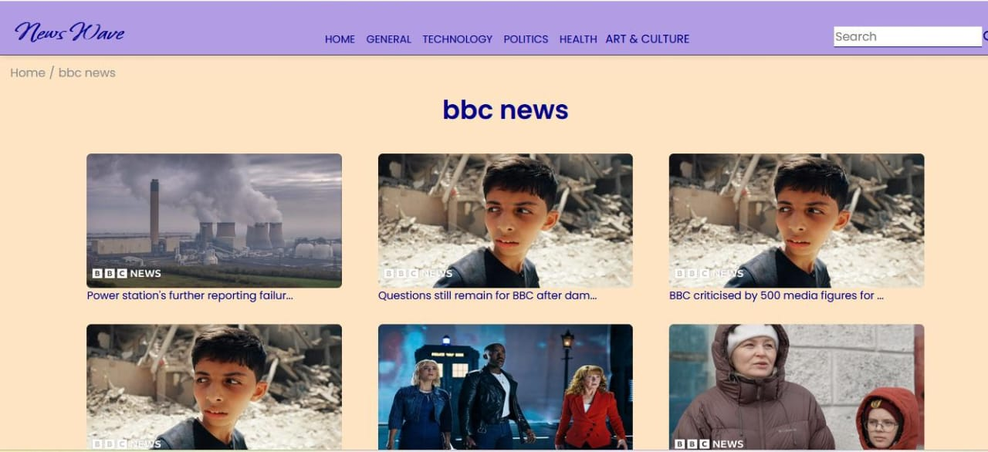
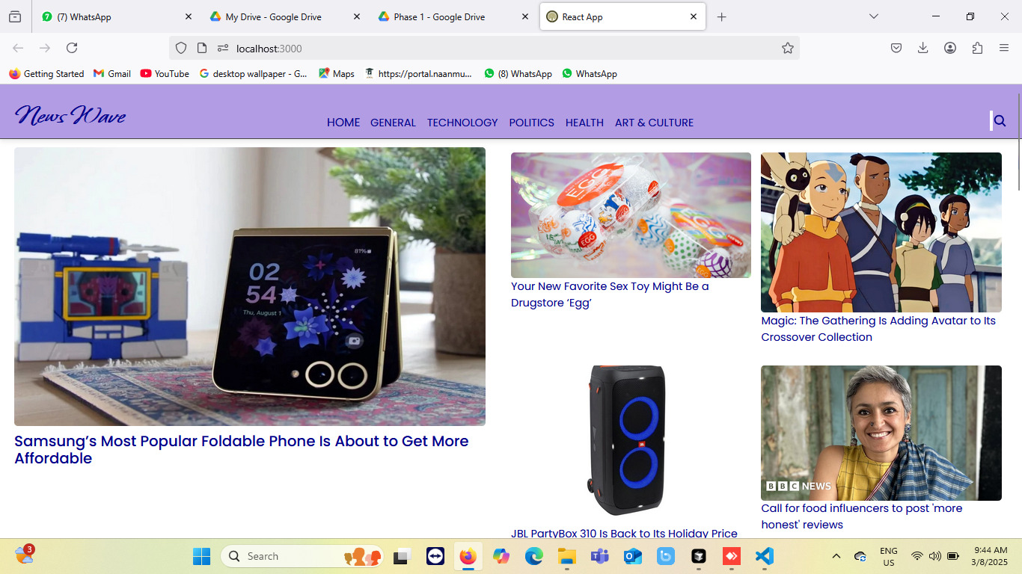
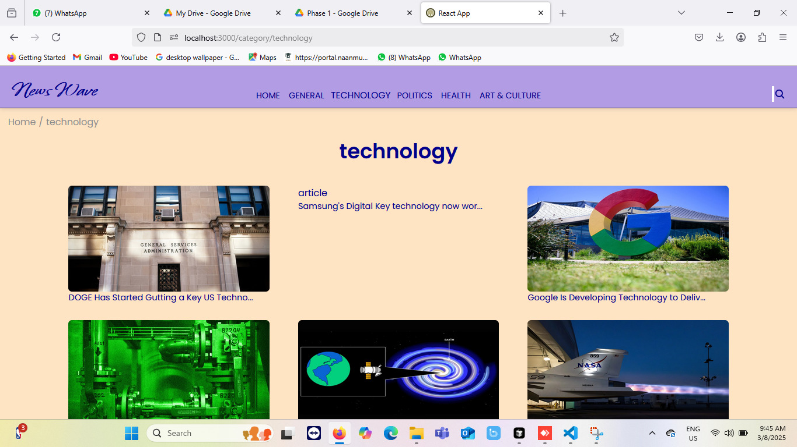

Known Issues
- API rate limits may restrict news fetching
- Some categories may not return results due to API limitations

Future Enhancements
- User authentication for personalized news feed
- Offline support with cached news
- Push notifications for breaking news

